Usiel Figueroa

June 09, 2025

CSD 430-A311 Server-Side Development

Module 4 Assignment: JavaBean

Purpose: To create a JavaBean class that holds data for highlights of Washington State,

using JSP for dynamic display.

JavaBean

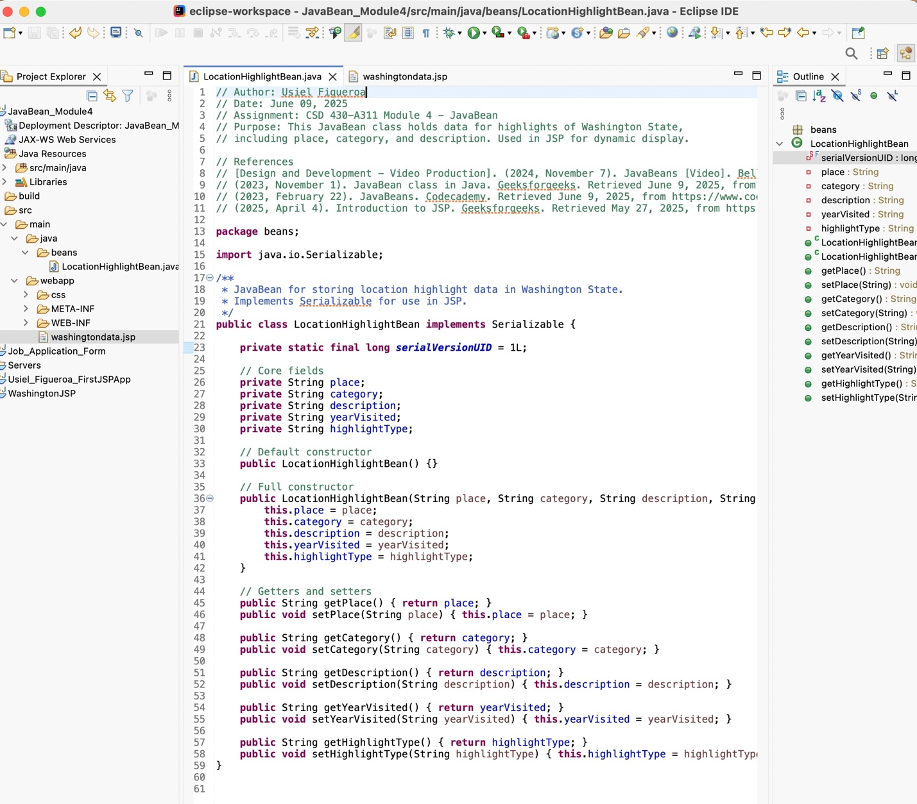

JSP Data

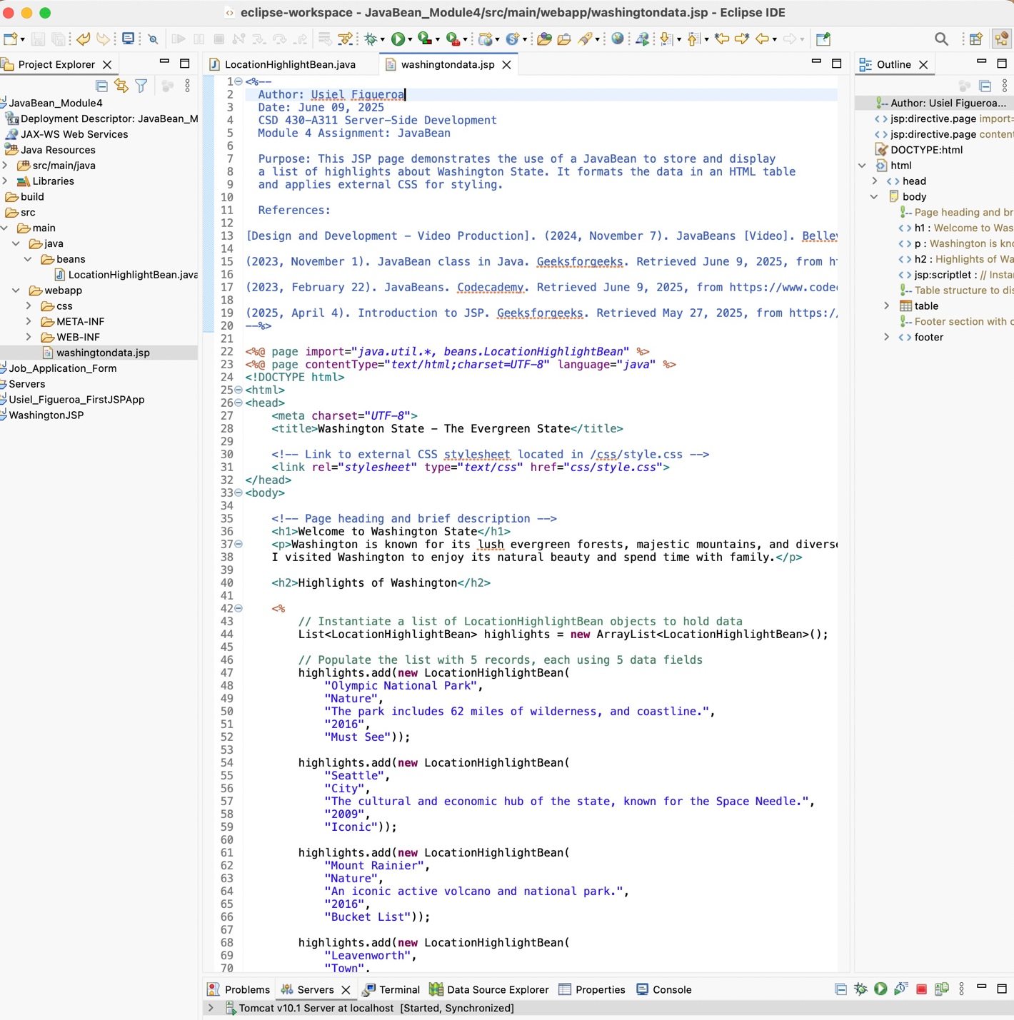

Website Display

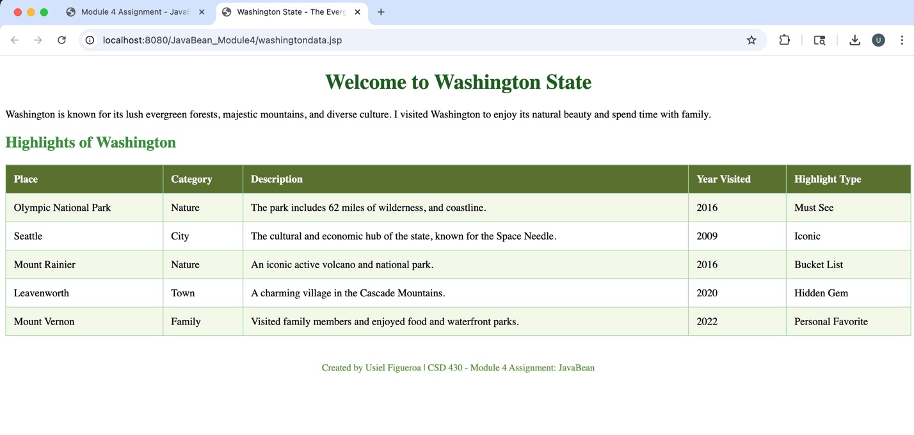

**References**

[Design and Development - Video Production]. (2024, November 7). JavaBeans [Video]. Bellevue University. <https://bellevue.mediaspace.kaltura.com/media/JavaBeans/1_8ssdtanr>

(2023, November 1). JavaBean class in Java. Geeksforgeeks. Retrieved June 9, 2025, from <https://www.geeksforgeeks.org/javabean-class-java/>

(2023, February 22). JavaBeans. Codecademy. Retrieved June 9, 2025, from <https://www.codecademy.com/resources/docs/java/javabeans>

(2025, April 4). Introduction to JSP. Geeksforgeeks. Retrieved May 27, 2025, from <https://www.geeksforgeeks.org/introduction-to-jsp/>